
Green Society Public School
D- 10
Ratnanagar-7, Sauraha, Chitwan
Annual Examination-2082
Class: Five Time: 2 hrs. F.M.:50
Sub: Maths
1. From the given figure alongside, answer the following questions. [3]
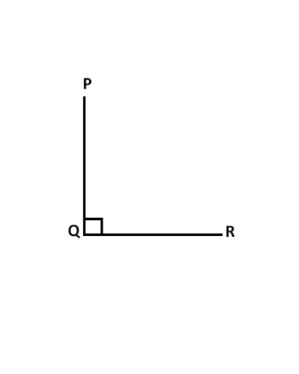
(a) Name the arms and vertex of given angle.
(b) Measure the given angle by using Protractor.
(c) Name the type of angle, on the basis of measurement.
2. Look at the figure and answer the following questions:
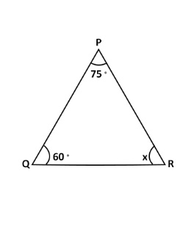
- Name the Triangle and its sides. [1]
- Find the sum of ∠ P and ∠ Q. [2]
- Find the value of ∠ R. [2]
3. The price of house in Ratnanagar is Rs 30720485.
(a) Write the number according to national system by using comma. [1]
(b) Write the number 30720485 into words. [1]
(c) Present the given number in the place value table according to national system. [2]
(d) Round off 798 nearest to ten. [1]
4. In a Mathematics exam, Sairan obtain 12 out of 20 full marks.
(a) Write the marks obtained by Sairan in fraction in lowest term. [2]
(b) Find the percentage obtained by Sairan. [2]
5. (a) Write P for Prime and C for Composite. [1]
12 - 31 -
(b) Write first 7 prime numbers [2]
(c) What is your roll number in class? Also mention either it is prime or composite. [2]
6. Represent the following numbers in place value table. [2]
(a) 2.8 (b) 4.75
(b) Write each number word as a decimal [2]
(i) Seven and eighteen hundredths.
(ii) Four and five tenths.
7. Multiply. [1] (a)
a) kg g
25 250
× 2
(b) Divide [1]
$$5√10 20 25$$
(c) The length of a basketball court is 28 and 65 m. What will be the length of 3 basketball courts? [2]
(d) Multiply 25l 500ml by 4. [2]
8. A rectangular volleyball court has length 18 m and breadth 9 m. [4]
(a) What is the formula to find perimeter of court?
(b) Find the perimeter of rectangular volleyball court.
9. Ramlal bought 10 kg rice at Rs 50 per kg, 2 kg potatoes at Rs 20 per kg, 3 dozen bananas at Rs 35 per dozen and 5 kg sugar at Rs 100 per kg from Pabitra Kirana Store, Tandi. Prepare a bill for the given purchase. [4]
10.Draw a bar graphs of following data. [2]
The population of 7 provinces according to population census 2021.
Provinces | Koshi | Madesh | Bagmati | Gandaki | Karnali
Population in percent | 17 | 21 | 18 | 6 | 9

11. (a) How many terms are there in the expression 4x + 36. [1]

(b) Find the sum [1]
2a + 3b and 3a + 4b

(c) Subtract second term from the first term. [1]
12a and 8a

(d) What is the sum of 5x and 6x? [1]

12. (a) Solve: [2]
(i) x - 5 = 7
(ii) g + 10 = 93

(b) If 3 is added to twice of a number, the sum will be 21. What is the number? [2]
The End

